Data models

Aitrich Technologies Pvt. Ltd.
© All rights reserved.

Data models
A data model is a collection of concepts that can be used to describe the structure of a database.
A Data Model is a way to organize the data that you have, it gets the information and using a set of rules it makes sure that the data is good quality for you to use.
Data Models are normally used to get data in, merge already existing data and to get data out. Data Models are also used for people that are working on the same project but in different groups to communicate.
There are multiple different Data Models, each one has its own befits and problems through each one is designed for a certain job.

Contents

- Type of data models
- Comparison
- Schema and instances
- Database views

Type of data models
Data models can be broadly distinguished into 3 main categories-
1) Conceptual or high-level data models (based on entities & relationships)
It provides concepts that are close to the way many users perceive data.
2) Implementation or representational data models (record-based, object-oriented)
It provides concepts that can be understood by end users. These hide some details of data storage but can be implemented on a computer system directly.
2) Physical or lowlevel data models
It provides concepts that describe the details of how data is stored in the computer. These concepts are meant for computer specialist, not for typical end users.

- Conceptual or high level data models
A high-level model of the data, describing what is stored. The conceptual data model is often presented in the form of a written document, which describes the data using high-level concepts such as objects and relationships. It is often used in the initial planning phase.
Examples (UML) and Entity-Relationship models.
A conceptual data model identifies the highest-level relationships between the different entities. Features of conceptual data model include:
- Includes the important entities and the relationships among them.
- No attribute is specified.
- No primary key is specified.
The figure below is an example of a conceptual data model.
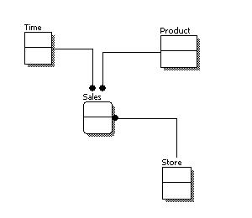

From the figure above, we can see that the only information shown via the conceptual data model is the entities that describe the data and the relationships between those entities. No other information is shown through the conceptual data model.

- Implementation or representational data models

An intermediate level describing how the data is logically organized. This is often presented as a description of the interface to the DBMS, and describes the data using medium-level concepts such as relations or sets.
Examples: relational models and network models.

A logical data model describes the data in as much detail as possible, without regard to how they will be physical implemented in the database. Features of a logical data model include:
- Includes all entities and relationships among them.
- All attributes for each entity are specified.
- The primary key for each entity is specified.
- Foreign keys (keys identifying the relationship between different entities) are specified.
- Normalization occurs at this level.
The steps for designing the logical data model are as follows:
- Specify primary keys for all entities.
- Find the relationships between different entities.
- Find all attributes for each entity.
- Resolve many-to-many relationships.
- Normalization.
The figure below is an example of a logical data model.
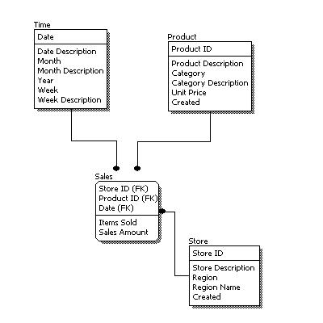

- Physical or lowlevel data models
A very low-level compared to the conceptual and implementation models, and describes how the data is physically stored. This is often expressed in the form of commands in a control language, using concepts like record formats or index files. The implementation model can be defined in the statements that create the database, such as part of the SQL language.
Example CREATE TABLE or CREATE INDEX.
Physical data model represents how the model will be built in the database. A physical database model shows all table structures, including column name, column data type, column constraints, primary key, foreign key, and relationships between tables. Features of a physical data model include:
- Specification all tables and columns.
- Foreign keys are used to identify relationships between tables.
- Denormalization may occur based on user requirements.
- Physical considerations may cause the physical data model to be quite different from the logical data model.
- Physical data model will be different for different RDBMS. For example, data type for a column may be different between MySQL and SQL Server.
The steps for physical data model design are as follows:
- Convert entities into tables.
- Convert relationships into foreign keys.
- Convert attributes into columns.
- Modify the physical data model based on physical constraints / requirements.
The figure below is an example of a physical data model.
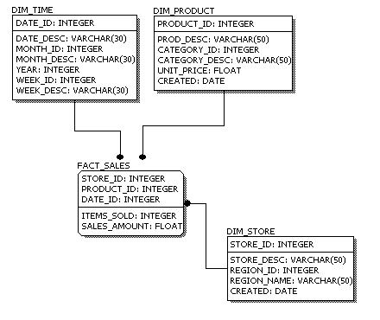

Comparison between 3 models

Feature | Conceptual | Implemental | Physical
Entity names
Entity relationships
Attributes
Primary keys
Foreign keys
Table names
Column names
Column datatypes

The complexity increases from conceptual to logical to physical. This is why we always first start with the conceptual data model (so we understand at high level what are the different entities in our data and how they relate to one another), then move on to the logical data model (so we understand the details of our data without worrying about how they will actually implemented), and finally the physical data model (so we know exactly how to implement our data model in the database of choice). In a data warehousing project, sometimes the conceptual data model and the logical data model are considered as a single deliverable.

Schemata and Instances
Schemata and instances are key concepts in databases.
A schema is a description of a database in some data model. If we compare the database to a programming language, then the schema can be compared to the data types represented by the programming language.
Example: schema Student (MetricNo, Name, Registered, CouncellorNo)

In computer programming, a schema is the organization or structure for a database. The activity of data modeling leads to a schema. (The plural form is schemata. The term is from a Greek word for "form" or "figure." Another word from the same source is "schematic.") The term is used in discussing both relational databases and object-oriented databases. The term sometimes seems to refer to a visualization of a structure and sometimes to a formal text-oriented description.
Schemas are generally stored in a data dictionary. Although a schema is defined in text database language, the term is often used to refer to a graphical depiction of the database structure.
Two common types of database schemata are the star schema and the snowflake schema.
Star schema
In the star schema design, a single object (the fact table) sits in the middle and is radially connected to other surrounding objects (dimension lookup tables) like a star. Each dimension is represented as a single table. The primary key in each dimension table is related to a foreign key in the fact table.

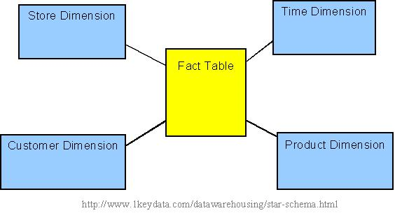
Sample star schema

All measures in the fact table are related to all the dimensions that fact table is related to. In other words, they all have the same level of granularity.
A star schema can be simple or complex. A simple star consists of one fact table; a complex star can have more than one fact table.
Let's look at an example: Assume our data warehouse keeps store sales data, and the different dimensions are time, store, product, and customer. In this case, the figure on the left repesents our star schema. The lines between two tables indicate that there is a primary key / foreign key relationship between the two tables. Note that different dimensions are not related to one another.
Snowflake schema
The snowflake schema is an extension of the star schema, where each point of the star explodes into more points. In a star schema, each dimension is represented by a single dimensional table, whereas in a snowflake schema, that dimensional table is normalized into multiple lookup tables, each representing a level in the dimensional hierarchy.

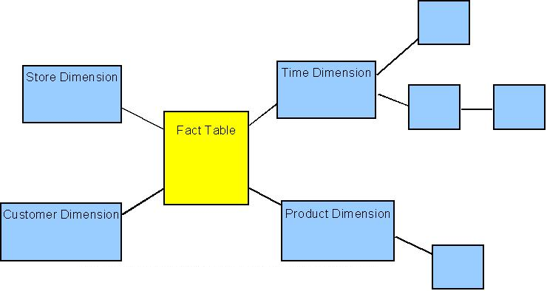
Sample snowflake schema
For example, the Time Dimension that consists of 2 different hierarchies:
1. Year → Month → Day
2. Week → Day
We will have 4 lookup tables in a snowflake schema: A lookup table for year, a lookup table for month, a lookup table for week, and a lookup table for day. Year is connected to Month, which is then connected to Day. Week is only connected to Day. A sample snowflake schema illustrating the above relationships in the Time Dimension is shown to the right.
The main advantage of the snowflake schema is the improvement in query performance due to minimized disk storage requirements and joining smaller lookup tables. The main disadvantage of the snowflake schema is the additional maintenance efforts needed due to the increase number of lookup tables.

Instances
An instance is a collection of data that corresponds to a schema. Again, using the comparison with the programming language, the instance corresponds to the variables in the programming language.

The term instance is typically used to describe a complete database environment, including the RDBMS software, table structure, stored procedures and other functionality. It is most commonly used when administrators describe multiple instances of the same database. Also Known As: environment
Examples1: An organization with an employees database might have three different
instances: production (used to contain live data), pre-production (used to test new
functionality prior to release into production) and development (used by
database developers to create new functionality).
Example2: instances for student

 | Name | Registered | CouncellorNo
S01 | Bloggs | 2005 | 4523
S02 | Smith | 2003 | 3412
S03 | MacDonald | 2004 | 4523

Database views
Not all users should, or need, to have access to all data held within the database. This can be controlled at the schema level. A database view is a type of schema that sits a level above the actual schema and controls what the user can see. Such views are often referred to as external schemas. There are two main reasons for using views: restricting access and generating data.

Restricting access:
This may be important, since you do not want all users to be able to access all data. For example, consider a simple database which a bank may be using to hold details of customer accounts. The bank database will have a number of different levels of user. The following may be an appropriate set of restrictions that may apply to a teller user of the bank's system:
- Operations: it may be appropriate to prevent a teller user allocating or updating a customer's overdraft limit.
- Fields: it may be appropriate to prevent the teller user from accessing the customer's overdraft status.
- Individual Records: it may be appropriate that only the bank's credit controller is able to see records for customers who have a negative balance on their account.
- Groups of Records: it is reasonable to stop the teller user from accessing employee records.

Generating data:
This is a common technique in database systems. It is not always necessary to store items of data that can be generated from other items of data in the database. For example, the age of a person can be calculated from their date of birth - it is not therefore important to store the age as a separate field. A database view can be used to control access to such generated data items, so that as far as the user is concerned the item of data is actually stored in the database.
Data modeling
Data modeling is a technique that is widely used in the world of business and information technology to show how information is, or should be, stored and used within a business system.
Data modeling is a technique aimed at optimizing the way that information is stored and used within an organization. It begins with the identification of the main data groups, for example the invoice, and continues by defining the detailed content of each of these groups. This results in structured definitions for all of the information that is stored and used within a given system.
The technique provides a solid foundation for systems design and a universal standard for system documentation. Data modeling is an essential precursor to analysis & design, maintenance & documentation and improving the performance of an existing system.

Contents

- What is Entity Relationship Model(E-R Model)
- Entities, Entity Types and Attributes
- Relationships
- Developing E-R diagrams
- Relational model

Data modelling-Diagram notation
Data modeling uses a standard set of symbols to represent each of these defined data groups and then proceeds by establishing the relationships between them. The first of these symbols is the soft-box entity symbol.

Invoice

An entity is something about which data will be stored within the system under consideration. In this example the data group invoice can be identified as a system entity.
The other main component on a data model is the relationship line. A Relationship is an association between two entities to which all of the occurrences of those entities must conform.
Entity1
Entity2

The relationship is represented by a line that joins the two entities, to which it refers. This line represents two reciprocal relationships: That of the first entity with respect to the second, and that of the second entity with respect to the first.
Data modeling is all about identifying entities and their relationships and then drawing a diagram that accurately depicts the system. This applies equally to the design of a new system or the analysis of an existing one.
The end result of data modeling should be a clear picture of how information is stored and related within a proposed, or existing, system.

Entity Relationship Model
The entity relationship model is a well established approach to the design of database systems. The focus of the technique is on the data represented (as a number of entities in which we have an interest), and the relationships between the data.

Components of the E R Model
The entity relationship model is a conceptual level data model. This conceptual model is represented through the three key components: entity types, attributes and relationships.

Entities
An entity represents a thing about which data is recorded. An entity may represent a tangible object, such as a student (John Perkins) or a vehicle (A 34761). It can often represent intangible objects, such as enrolment or order.
Eg: Banking system: Customer, Account, Loan.
Airline system: Aircraft, Passenger, Flight, Airport.
An entity is represented by a box containing the name of that entity.
Note that entities are always named in the singular; for example: customer, account and loan, and not customers, accounts and loans.

Entity types
An entity type defines the properties of a collection of entities. For example, a Student with Name, Matriculation Number and Date of Registration.

Attribute
An attribute is a component of an entity that represent a single property of entities of that type. The attributes of the student entity type are Name, Matriculation Number and Date of Registration.

One or more attributes may be chosen to be the identifier of an entity. The identifier is the attribute that helps us distinguish one entity from another entity of the same type. For example the matriculation number would be a suitable identifier for a student entity.

It is advantageous to introduce a notation what allows us to graphically represent the developing ER model - such a notation allows us to represent an ER model as an ER diagram

Example entity
Example of an entity
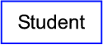

Entities can also be written textually to show all of the attributes
Student(MatricNo, Name, Registered)

The identifier of the entity is shown underlined - the identifier is the attribute that will be used to distinguish one entity instance from another -

Relationships
A relationship is an association between entities that needs to be recorded.

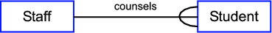

The particular relationship concerns the counseling relationship between these entity types. The relationship is initially illustrated by drawing a connecting line between the two entity types affected by the relationship. The relationship is itself then named for clarity.

The Degree of a Relationship
The degree of a relationship governs the maximum number of entities that participate in the relationship.

1:1: This is referred to as a one to one relationship

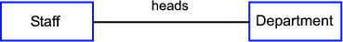

1:N: This is referred to as a one to many relationship and states that one entity may relate to more than one other entity.

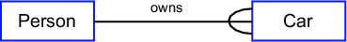

M:N: This is referred to as a many to many relationship.

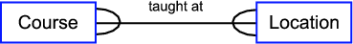

A relationship may exist between different entities of the same type. This example, shows the relationship between instances of the Person entity. The relationship is shown to be married to, which captures the fact that one instance of the Person entity may be married to another instance of the Person entity.

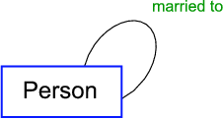

Relationship Occurrence
If you don’t know what the relationship is between entities then it is sometimes useful to look at existing records for relationship occurrences.
A relationship occurrence is a specific set of associations that exist at a given time. These can be captured in an occurrence diagram.

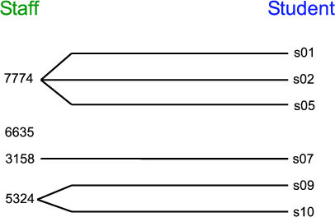

This shows the counsels relationship between the Student and Staff. The occurrence diagram shows the associations between the entity identifiers. So, for example, the diagram shows that Staff number 7774 has a counsels relationship with Student s01, s02 and s05. This diagram further illustrates that certain Staff need not be associated with Students via this relationship; for example Staff number 6635 is not associated with any Student occurrences (and the relationship is therefore optional).

Participation Conditions
Participation conditions govern the minimum number of entities that participate in a relationship. There are two alternatives:
mandatory: every entity must participate in the relationship. A dot is placed adjacent to the entity which is mandatory.
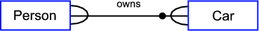
Each car must have an owner

optional: every entity may, or may not participate in the relationship. This is represented in the notation by an unfilled dot on the relationship line.

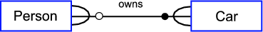
A Person entity may exist without having an associated Car

Many to Many relationships

If we have a many to many relationships then we need to think on how we are going to store that relationship attributes e.g. array of possible values.
In our example, the person entity could have an array of cars (if so how many?), and a car could be owned by a number of people (if so how many?)
It is often helpful to think of a new entity that would split the many to many tnto two one to many relationships

Constraints and Assumptions
Not all the data requirements can be captured using entities, attributes and relationships. Such items are simply recorded as constraints, i.e. assertions about the data. For example, a student may not enrol for more than 100 points worth of courses.
Typically, in order to construct an ER model, we must make assumptions about the data that are not stated in the data requirements. For example, a Student cannot enrol on a Course more than once.

Developing E-R diagrams
An Entity Relationship Diagram (ERD) is a snapshot of data structures. ERDs show entities in a database and relationships between tables within that database. It is essential to have one of these if you want to create a good database design. The patterns help focus on how the database actually works with all of the interactions and data flows, although another useful tool is a Data Flow Diagram (DFD) which more directly describes this.

Developing an ERD : Developing an ERD requires an understanding of the system and its components

University sample
Identify potential entities for the University:

What entities can you identify from the university data requirements?
Tangible things that you might identify as entities are Course and Assignment.
A list of entities could therefore be as follows:
Student, Staff, Course, Assignment
Identify attributes:
What are the attributes for the entities that have been identified?
Some attributes for the suggested entities are listed below:
Student(MatricNo, Name, Registered, CourseCode)
Staff(StaffNo, Name)
Course(CourseCode, Title, Credit, tutor)
Assignment(MatricNo, CourseCode, AssignmentNo, Grade)
Choose identifiers:
Choose identifiers for the entities from the attribute list provided in the previous step.
Candidate identifiers are shown by underling the attribute - remember that multiple attributes may be involved in forming the identifier.
Student(MatricNo, Name, Registered, CourseCode)
Staff(StaffNo, Name)
Course(CourseCode, Title, Credit, tutor)
Assignment( MatricNo, CourseCode, AssignmentNo, Grade)
Draw Initial ER Diagram:
Given the information from the above steps, draw out an initial ER diagram - representing the entity types in the rectangles.
Draw Initial ER Diagram:

Staff
Student
Assignment
Course

Staff
Staff
Staff
Staff

Add Relationship Information:
Referring to the text description, draw relationships between the entities on the draft ER diagram.

Staff
Student
Assignment
Course

Councels Tutors

Enrol

has has

Add Degree Information:
From the text information, identify any additional information concerning the degree of relationships between entities. Add this information to the draft ER diagram.

Staff
Student
Assignment
Course

Councels tutors

Entol

Has has

Add Participation Information:
From the text information, identify any additional information concerning the participation of entities in the relationships identified.Add this information to the developing ER diagram
Staff
Student
Assignment
Course
Has
Has

Counsels tutors

Constraints and Assumptions(Compile these as you are building the model)
No of students registered for a course cannot exceed the course quota Students cannot enroll for more than 100 credits An assignment cannot exit without being part of a course. If a student is not registered for a course then they have no assignments.An assignment can only be for one course.A course can only have one tutor.

Now we need to check if we are happy with our entities or should we redesign and remove the many to many relationships

As far as the university ER model is concerned this leads us to consider Enrolment as our final entity.
The full list of entities is therefore as follows:

Student, Staff, Course, Assignment, Enrolment

Identify attributes:
Sample attributes have already been provided for the Staff and Student entities. What are the attributes for the entities that have been identified?

The attributes for the suggested entities are listed below:
Student(MatricNo, Name, Registered)
Staff(StaffNo, Name)
Course(CourseCode, Title, Credit, tutor)
Enrolment(MatricNo, CourseCode)
Assignment(MatricNo, CourseCode, AssignmentNo, Grade)
Choose identifiers:
Choose identifiers for the entities from the attribute list provided in the previous step.

Candidate identifiers are shown by underling the attribute - remember that multiple attributes may be involved in forming the identifier.
Student(MatricNo, Name, Registered)
Staff(StaffNo, Name)
Course(CourseCode, Title, Credit, tutor)
Enrolment( MatricNo, CourseCode)
Assignment( MatricNo, CourseCode, AssignmentNo, Grade)

Draw Initial ER Diagram:
Given the information from the above steps, draw out
an initial ER diagram - representing the entity types in the rectangles.

Draw Initial ER Diagram:

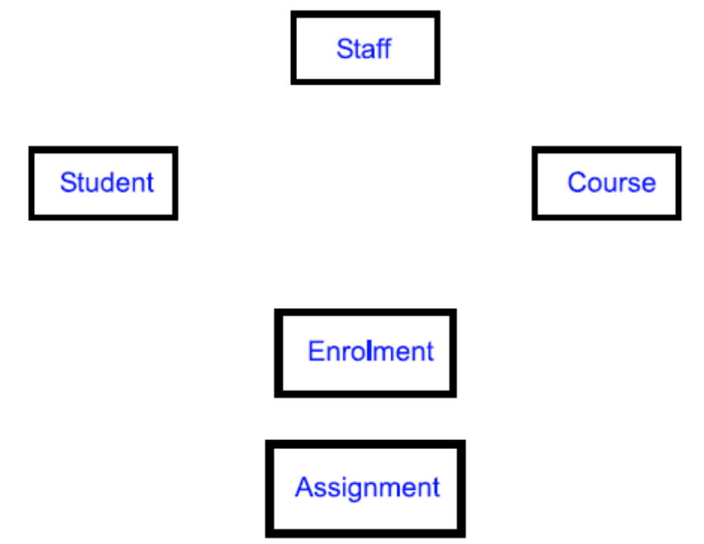

Add Relationship Information:
Referring to the text description, draw
relationships between the entities on the draft ER diagram

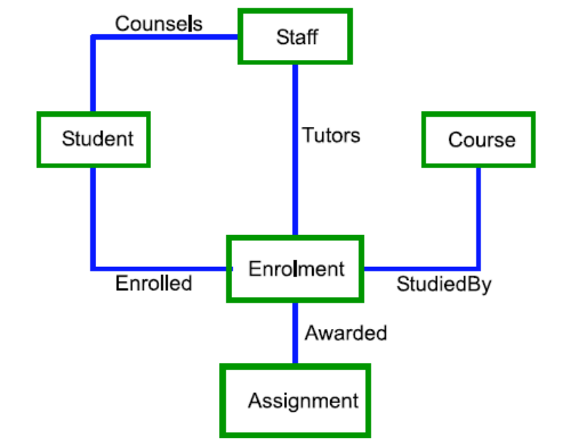

Add Degree Information:
From the text information, identify any additional information concerning the degree of relationships between entities. Add this information to the draft ER diagram.
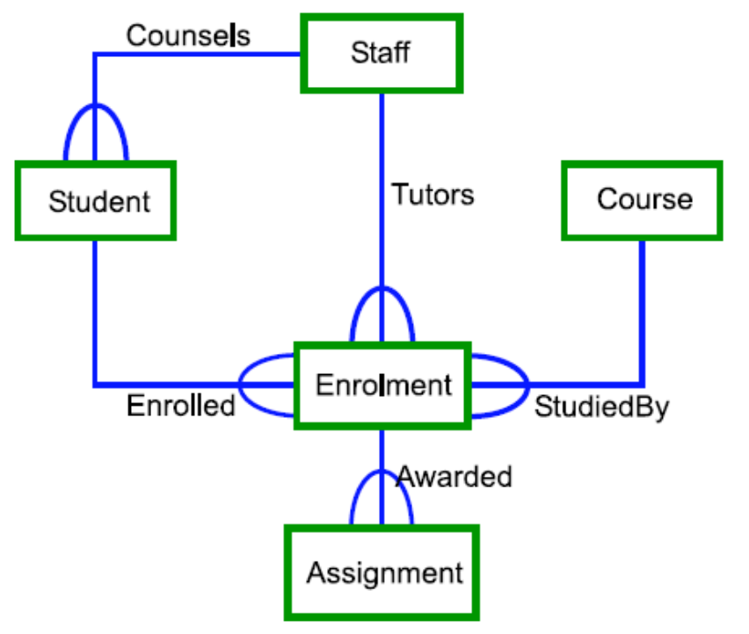

Add Participation Information:
From the text information, identify any additional information concerning the participation of entities in the relationships identified.Add this information to the developing ER diagram
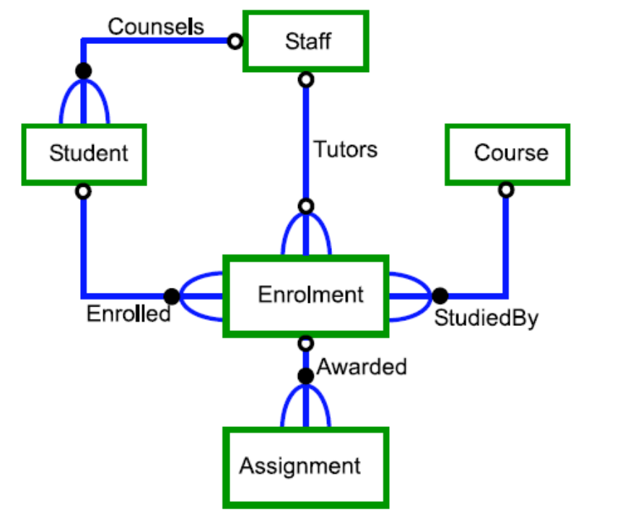

Relational model
Before proceeding to look at relational data modeling in detail, let us consider a comparison between the relational model and relational Database Management System (DBMS).
The relational model is concerned with what is required, which separates it from concerns of how the model will be implemented. The how is the concern of the relational DBMS.

The relational model focuses on representing data through relationships held between those data items. Data is represented in the form of tuples. The data in the relational model is queried/manipulated using relational algebra.
The Relational DBMS is concerned with how the relational model will be implemented. The data from the relational data model is represented in the form of tables and rows. The data is queried using particular query languages, most commonly this is a language known as SQL.

The Three Parts of the Relational Model

Structural: defines the core of the data and the relationships involved. The model structure is described in terms of relations, tuples, attributes and domains.

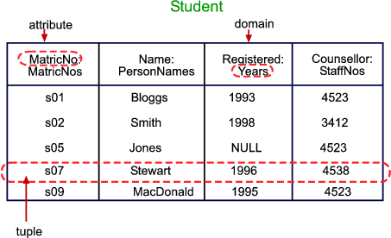

Manipulative: defines how the data in the model will be accessed and manipulated. This concerns how relations in the model will be manipulated to produce other relations, which in turn provide the answer to some question posed by a user of the data. The manipulation is achieved though relational algebra.

Constraints: defines limits on the model. The constraints determine valid ranges and values of data to be included in the model.

Describing the Model Structure

Relation: A relation comprises a set of tuples.
Tuple: A tuple is a sequence of attributes i.e. a row in the relation table.
Attribute: An attribute is a named column in the relation table.
Domain: The domain construct is important as it identifies the type of an attribute. More formally the domain is a named set of values which have a common meaning - the domain of an attribute defines the set of values from which an attribute can draw.

Null value
This is a special value that may be assigned to an attribute, however it is desirable to avoid assigning the NULL values as its meaning can be ambiguous. For example, with regard to the Student relation, the fact that the Registered attribute is shown to have a NULL value could mean that we do not know the year in question, or it could mean that the student has not in fact registered yet. Null values also causes problems with queries.

Properties of Relations
Relations have three important properties.
Name: The first property is that a relation has a name which identifies it.
Cardinality: The second property of a relation it its cardinality. This refers to the number of tuples in the relation.
Degree: The third and final property of a relation is its degree. The degree of a relation refers to the number of attributes in each tuple.

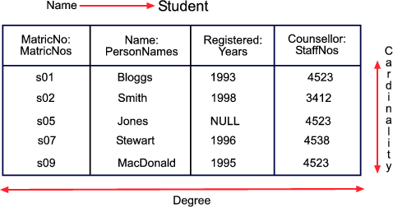

Domains
The domain of an attribute defines the set of values which can apply to that attribute.
MatricNos = s01..s99 PersonNames = string StaffNos = 1000..9999 Years = 1960..2040
MentorNos = 1000..9999

The most important consequence of two attributes being defined on the same domain is that their attribute values are comparable.

Notation to Describe the Relational Schema
There are two alternative notations
relation Student
MatricNo: MatricNos
Name: PersonNames
Registered: Years
Counsellor: StaffNos
primary key MatricNo
Student(MatricNo, Name, Registered, Counsellor)
We will use the first more detailed notation

Relational Schema keys

The notation identifies the key to the relation. The key is the attribute(s) that uniquely identifies one tuple in a relation from another.
There are many attributes that can be considered as candidate keys. One of the candidate keys is chosen as the primary key - this is the key that performs the unique identification of a given tuple.

Foreign keys
A relation will also often include one or more foreign keys. A foreign key is an attribute that represents a relationship with another relation: it is the primary key of one relation which is included as an attribute in another relation.

Representing an ER Model as a Relational Model
An entity relationship (ER) model can be represented as a lower level relational model.
  - Entity types map to Relations
  - Attributes map to Attributes
  - Identifiers map to Keys
  - 1:1 and 1:N relationships map to Foreign keys
  - M:N relationships map to Relations

Representing 1:1 Relationships

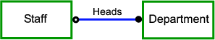

Entity types
Staff (StaffNo, Name)
Department (DeptNo, DeptName)

relation Staff
StaffNo: StaffNos
Name: PersonNames
primary key StaffNo
relation Department
DeptNo: DeptNos
DeptName: DeptNames
HeadOfDept: StaffNo
primary key DeptNo
foreign key HeadOfDept references Staff

Representing 1:N Relationships

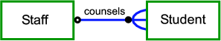

Student(MatricNo, Name, Registered)
Staff(StaffNo, Name)

relation Staff
StaffNo: StaffNos
Name: PersonNames
primary key StaffNo
relation Student
MatricNo: MatricNos
Name: PersonNames
Registered: Dates
Counsellor: StaffNos
primary key MatricNo
foreign key Counsellor references Staff

Representing M:N Relationships

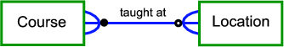

Course (CourseCode, Title, Credit)
Location (RoomNo, Capacity)

relation Course
CourseCode: CourseCodes
Title: CourseTitles
Credit: Integer
primary key CourseCode
relation Location
RoomNo: RoomNumbers
Capacity: Integer
primary key RoomNo
relation TaughtAt
CourseCode: CourseCodes
RoomNo: RoomNos
primary key (CourseCode, RoomNo)
foreign key CourseCode references Course
foreign key RoomNo references Location

This shows how the M:N relationship is captured through a separate relation, taught at. This additional relation has two attributes - these are both foreign keys as well as the primary key to each tuple in the relation.

